COURSE CODE/TITLE: | CPE212 |  | SECTION: | CPE31S2
DATE PERFORMED: |  |  | DATE SUBMITTED:
NAME: | Ace Tadalan |  | INSTRUCTOR: | Engr. Quejado

HOA NO.12 | Build a Sample Web App in a Docker Container
1. PROCEDURE OUTPUT
- Make sure you have the DEVASC Virtual Machine
- Refer to the following if you don't have the required VM
  - Download the appliance of the VM workstation here:
  - Instruction to import and install the ova:
- DEVASC_VM.ova

PART1
Installation
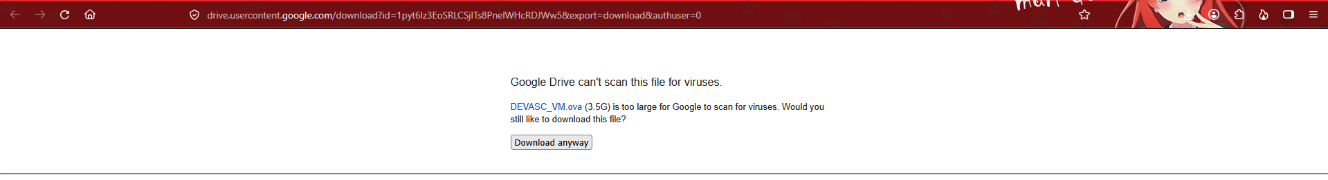

DEVASC LABVM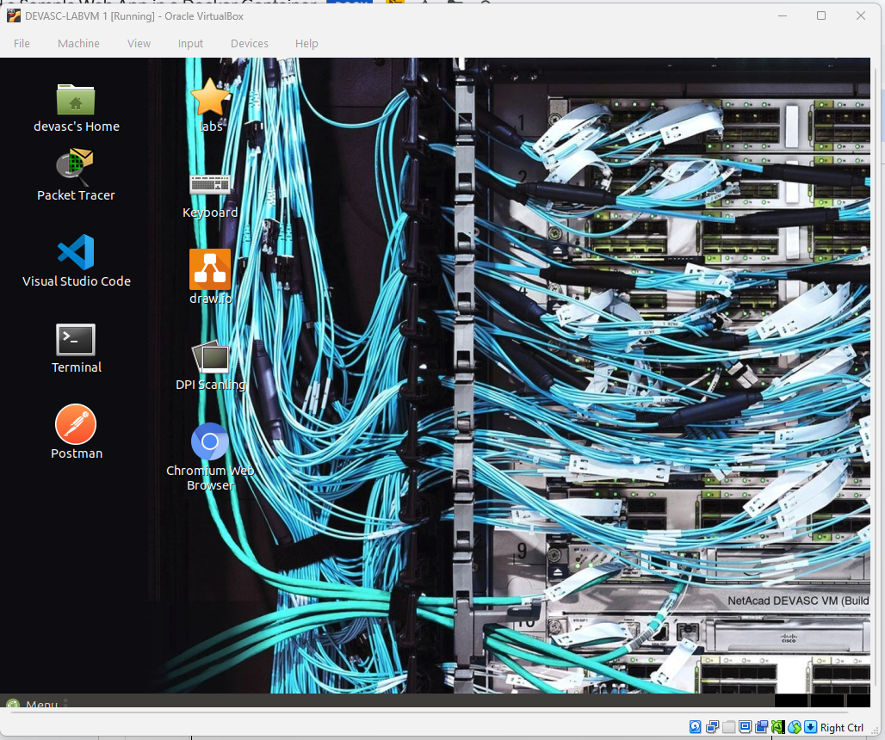

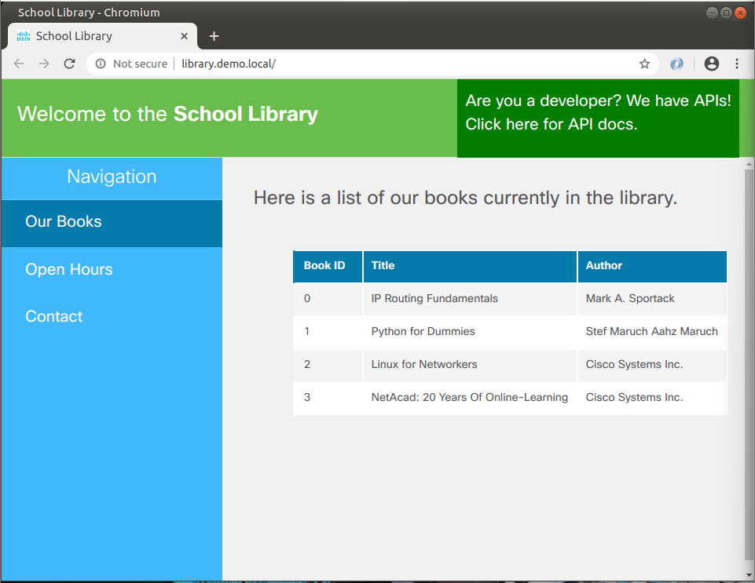

PART2
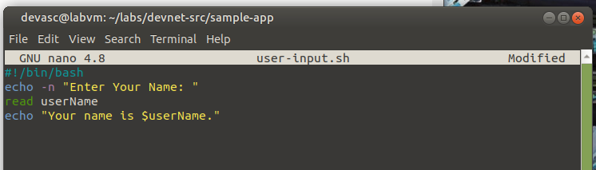

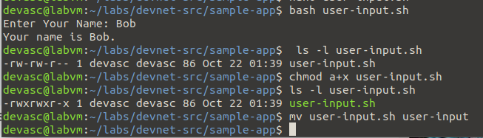

PART3
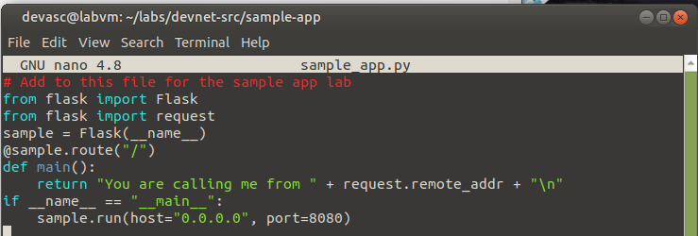

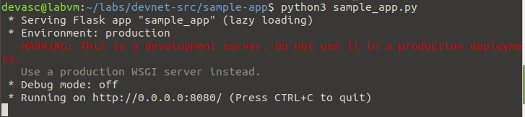

PART4
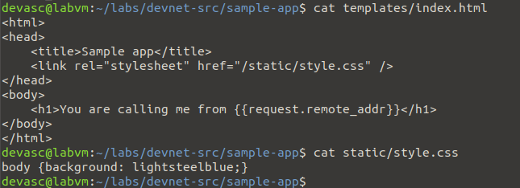

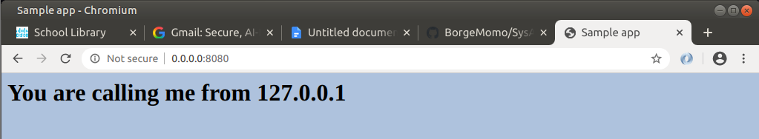

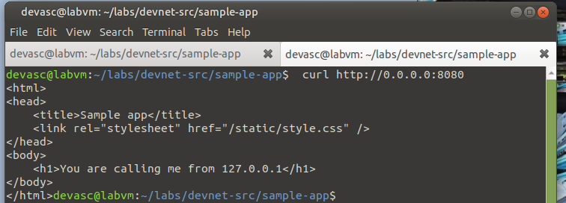

PART5
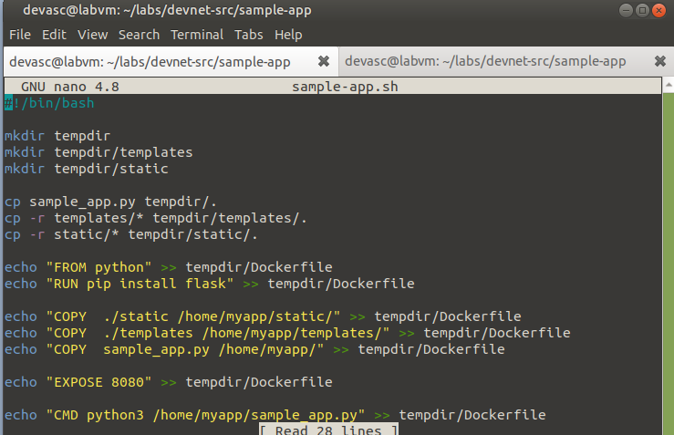

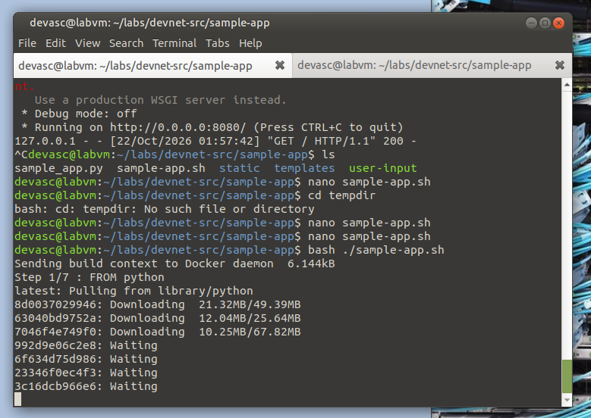

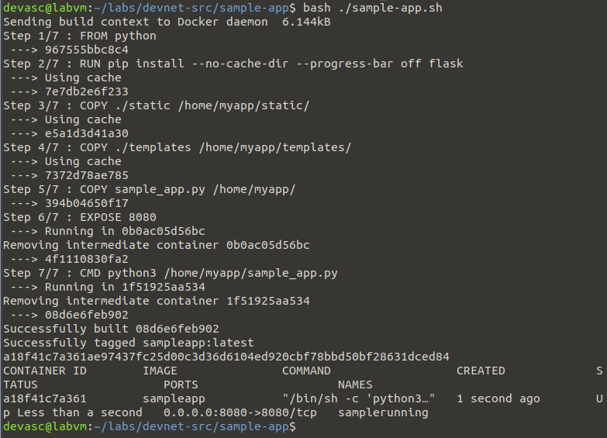
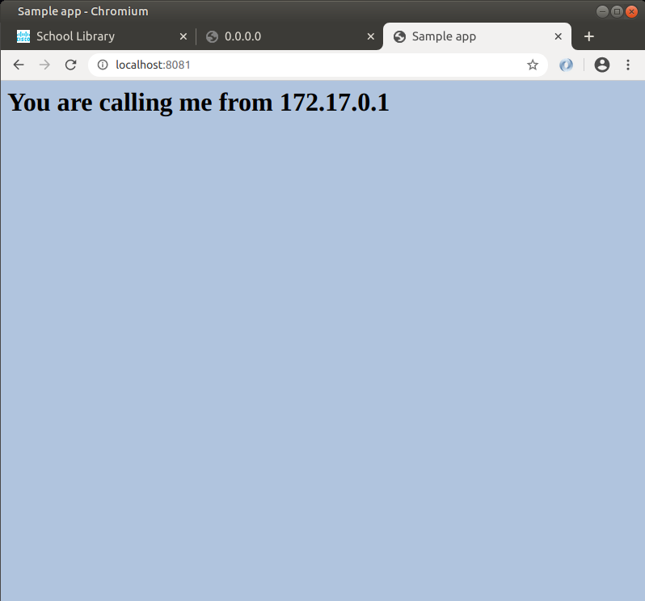
PART6
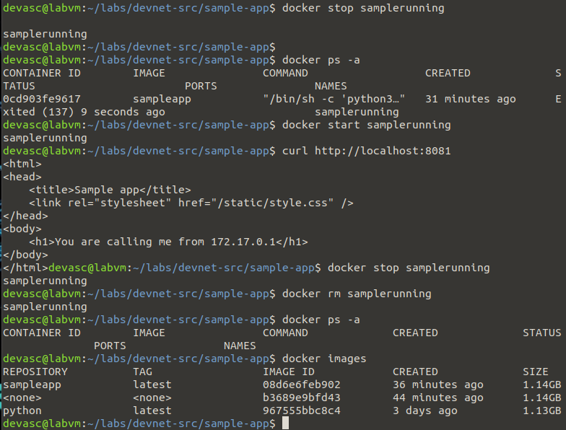

CONCLUSION

In this lab, I learned how to create a simple web application using Python and Flask. I also learned how to use Bash scripts to automate tasks. I successfully built and ran a Docker container for the application. I practiced checking the container, accessing the application, and managing its status. Overall, this activity helped me understand the basics of Docker and containerization.

2. ANSWERS TO SUPPLEMENTAL ACTIVITY
Copy and paste the questions from the lab and include your answers after.

3. ARTIFICIAL INTELLIGENCE (AI) USE DISCLOSURE STATEMENT
I hereby declare that artificial intelligence (AI) tools were used, if applicable, in the preparation of this academic work. The following indicates the nature and extent of AI assistance:

Tools Used:
Examples: ChatGPT, Microsoft Copilot, Grammarly, QuillBot, etc.

Purpose of Use:
Examples: grammar correction, idea generation, formatting, summarization, code assistance, explanation of concepts, etc.

Extent of Use:
Explain how AI was used and confirm that it did not replace original thinking, analysis, authorship, or completion of the required work.

By submitting this activity, I affirm that my use of AI complies with T.I.P.’s AI usage policy and does not exceed the permitted limits for similarity, automated content generation, or academic assistance.

I understand that any false, incomplete, or misleading disclosure may be subject to investigation in accordance with due process and may result in sanctions for violation of existing T.I.P. policies.

Lab activities, templates, and related instructional materials shall not be reuploaded, reproduced, distributed, or shared with external organizations or third parties without the prior express written permission of the Technological Institute of the Philippines.

